BEIF and Davis Langdon LLP
proudly present
a
PFI/PPP and Property Development Finance:

BURNS SUPPER
on
FRIDAY 11 FEBRUARY 2005

The Caledonian Club, 9 Halkin Street, LONDON SW1X 7DR

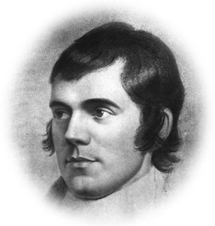

Chairmen

David Ainsley & Chris Elliott

Programme of Entertainment

Welcome……………………. | David Ainsley
Selkirk Grace……………… | Jim Boags
To a Haggis………………... | Douglas Gray
Loyal Toast………………… | Chris Elliott
Immortal Memory……….. | Stuart Lait
Song recital……………….. | Ronald Nairne (tenor)
……………………………….. | Laura Smith (piano)
To the host country……… | Michael Mainelli
Reply………………………... | Ashley Blows
To the lassies……………… | Dick Burge
Reply……………………….. | Clare Murdoch
Auld Lang Syne…………... | All
Carriages

Bill o’ Fare

Haggis and neeps

(“Great Chieftain o’ the puddin’ race”)

oOo

Roast sirloin of Scotch beef

(Wi’ a th’ trimmin’s)

oOo

Cheese & biscuits

(Lanark blue & Scottish farmhouse)

oOo

Coffee & Orkney tablet

oOo

Wines (tba)

Auld Lang Syne

Should auld acquaintance be forgot,

And never brought to mind?

Should auld acquaintance be forgot,

And days of auld lang syne?

And days of auld lang syne, my dear,

And days of auld lang syne.

Should auld acquaintance be forgot,

And days of auld lang syne?

We twa hae run aboot the braes

And pu’d the gowans fine.

We’ve wandered mony a weary foot,

Sin’auld lang syne.

Sin’ auld lang syne my dear,

Sin’ auld lang syne,

We’ve wandered mony a weary foot,

Sin’ auld lang syne.

We twa hae sported i’ the burn,

From morning sun till dine,

But seas between us braid hae roared

Sin’ auld lang syne.

Sin’ auld lang syne, my dear,

Sin’ auld lang syne.

But seas between us braid hae roared

Sin’ auld lang syne.

And ther’s a hand, my trusty friend,

And gie’s a hand o’ thine;

We’ll tak’ a cup o’ kindness yet,

For auld lang syne.

For auld lang syne, my dear,

For auld lang syne,

We’ll tak’ a cup of kindness yet,

For auld lang syne.

